Supporting Information
Enhanced Photocatalytic CO₂ Reduction Performance in Ni-Doped Perovskite Nanocrystals Controlled by Magnetic Fields

S1 Schematic diagram of catalyst synthesis device.
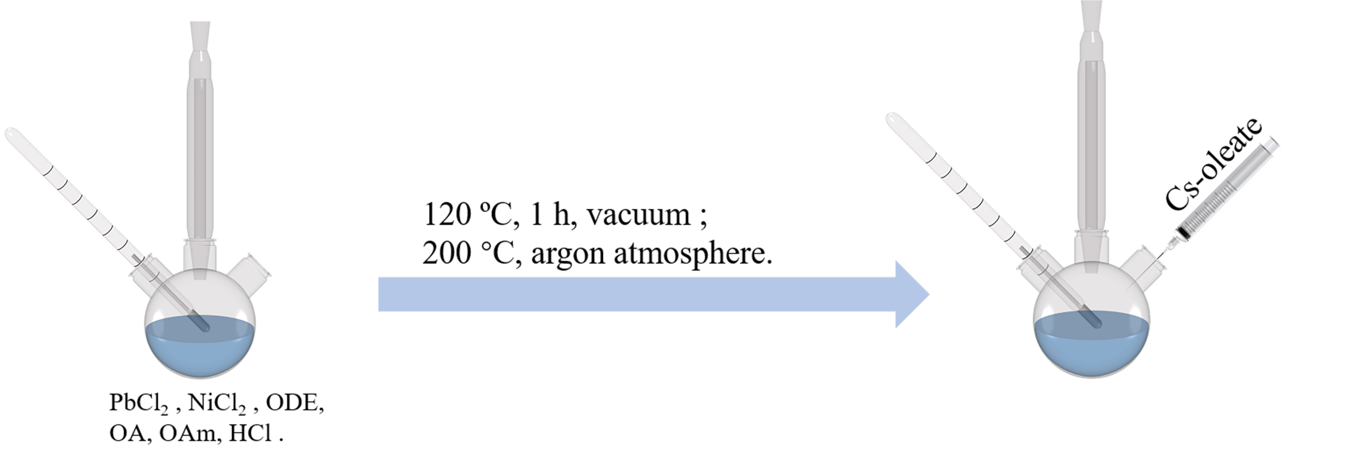
Figure S1 Schematic diagram of catalyst synthesis device.

S2 Schematic diagram of photocatalytic reaction with a magnetic field.
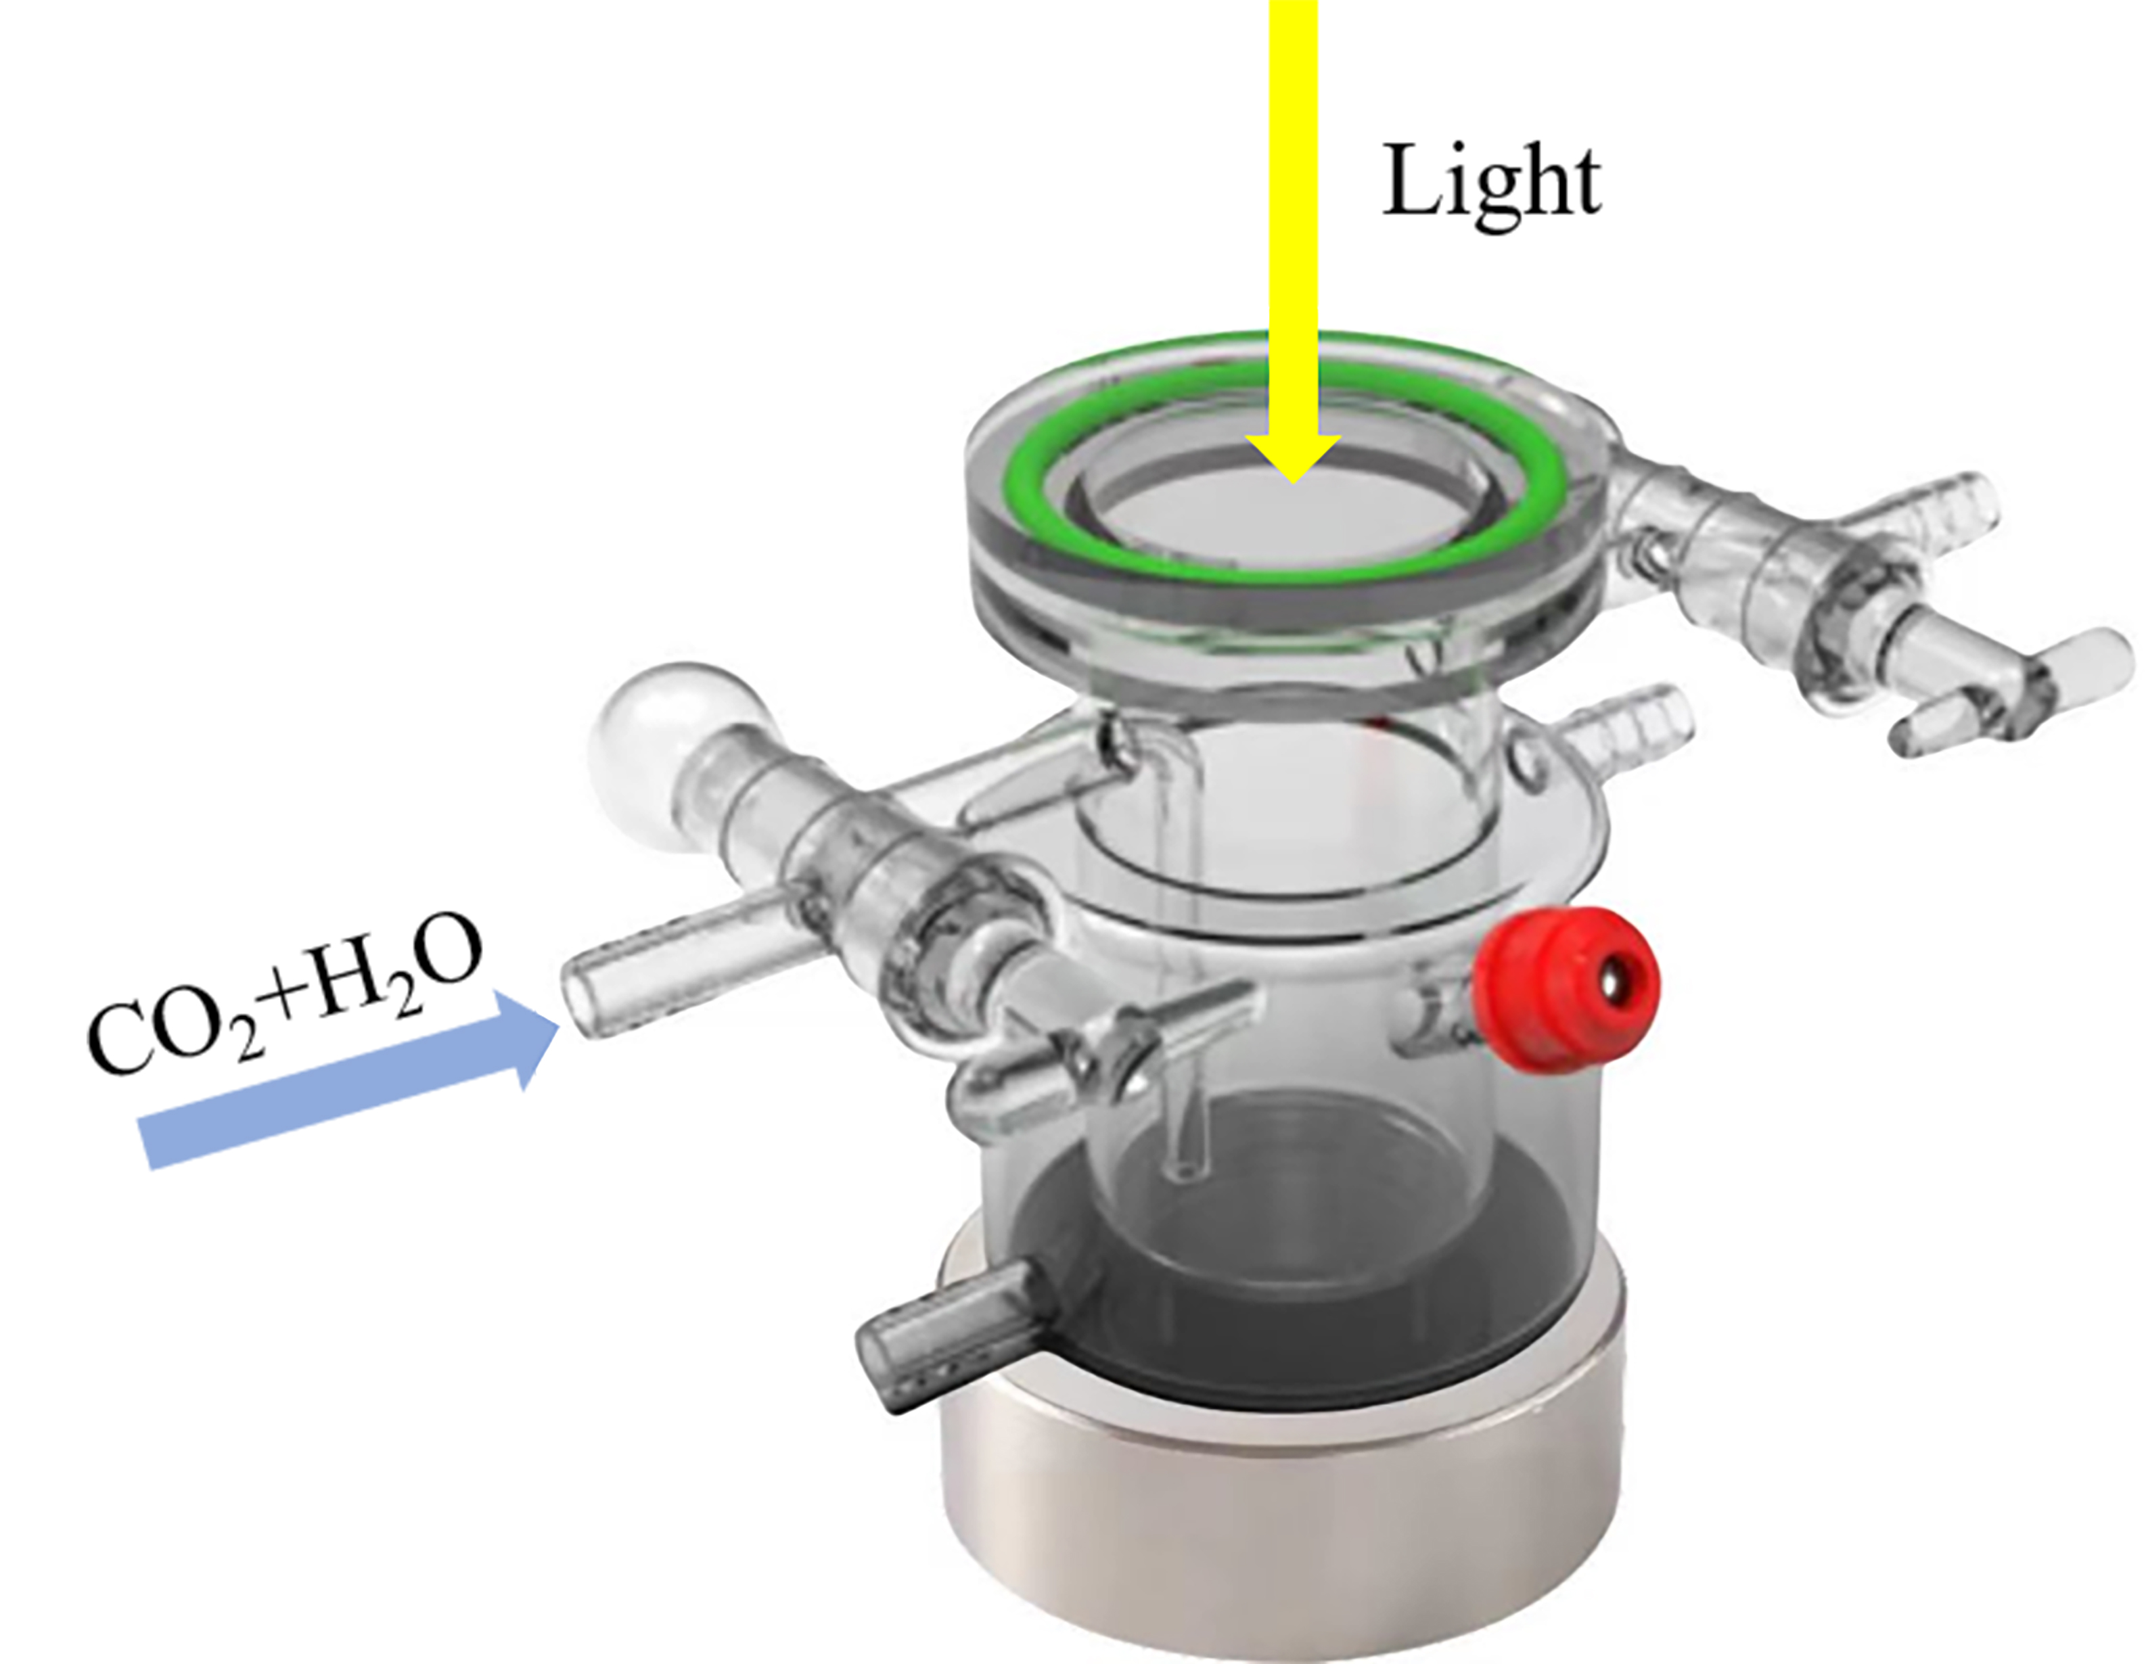
Figure S2 Schematic diagram of photocatalytic reaction with a magnetic field.

S3 XPS of Ni-CsPbCl₃ with a doping ratio of 8.0 at. %.
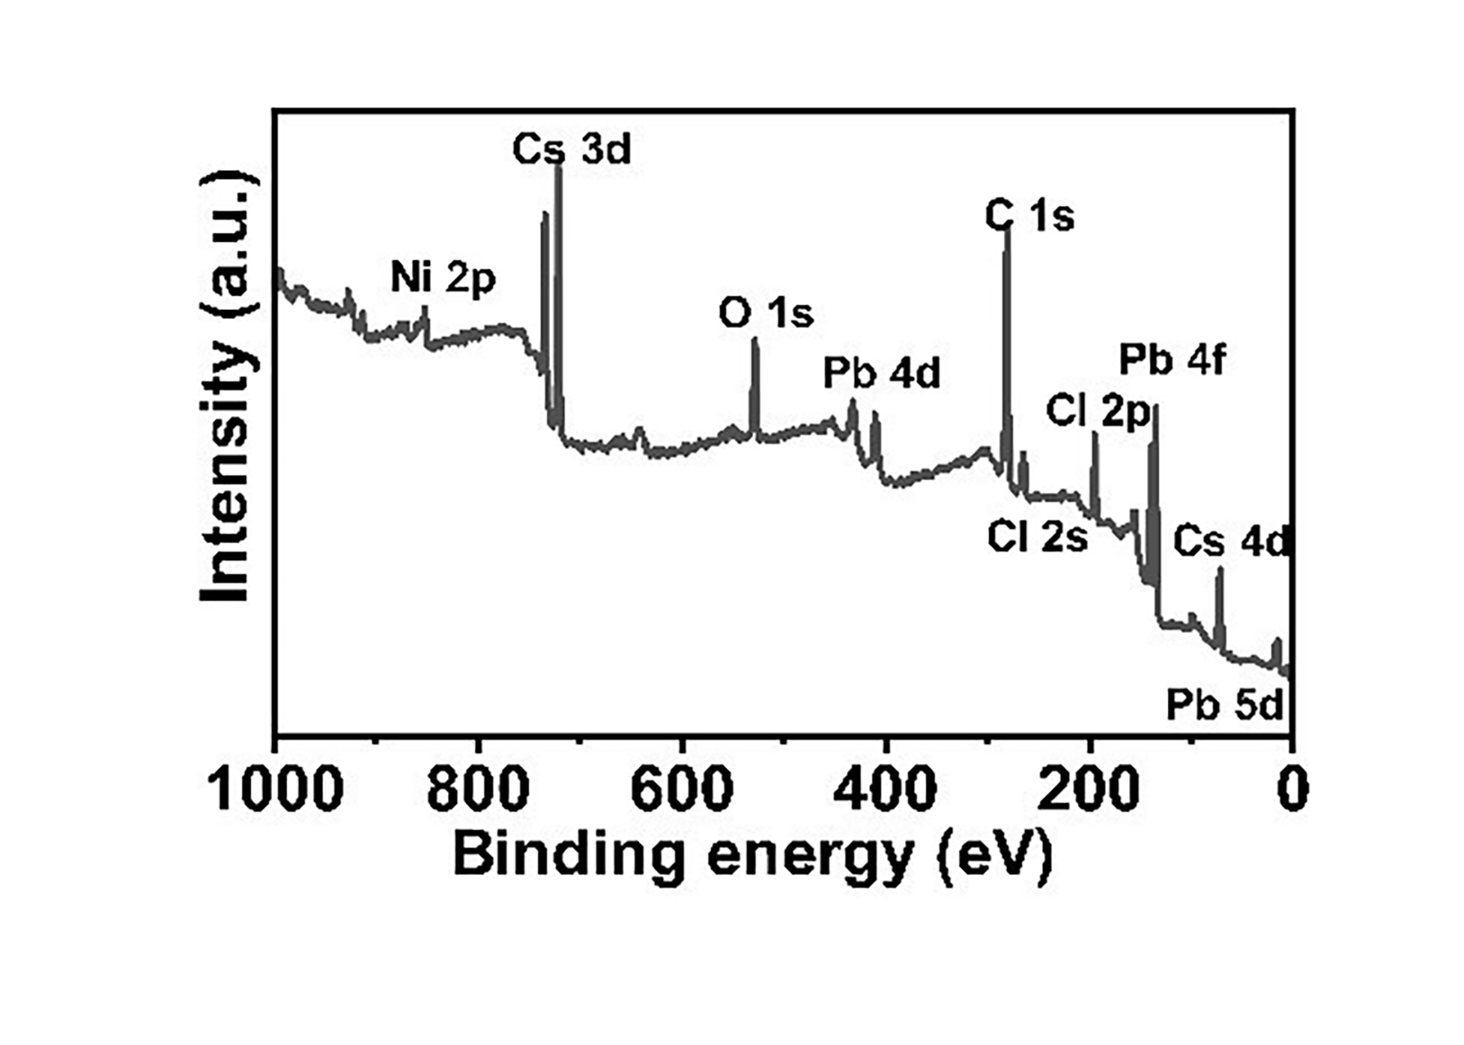
Figure S3 XPS of Ni-CsPbCl₃ with a doping ratio of 8.0 at. %.

S4 The product yields of Ni-CsPbCl₃ with various Ni doping ratios in an argon atmosphere.
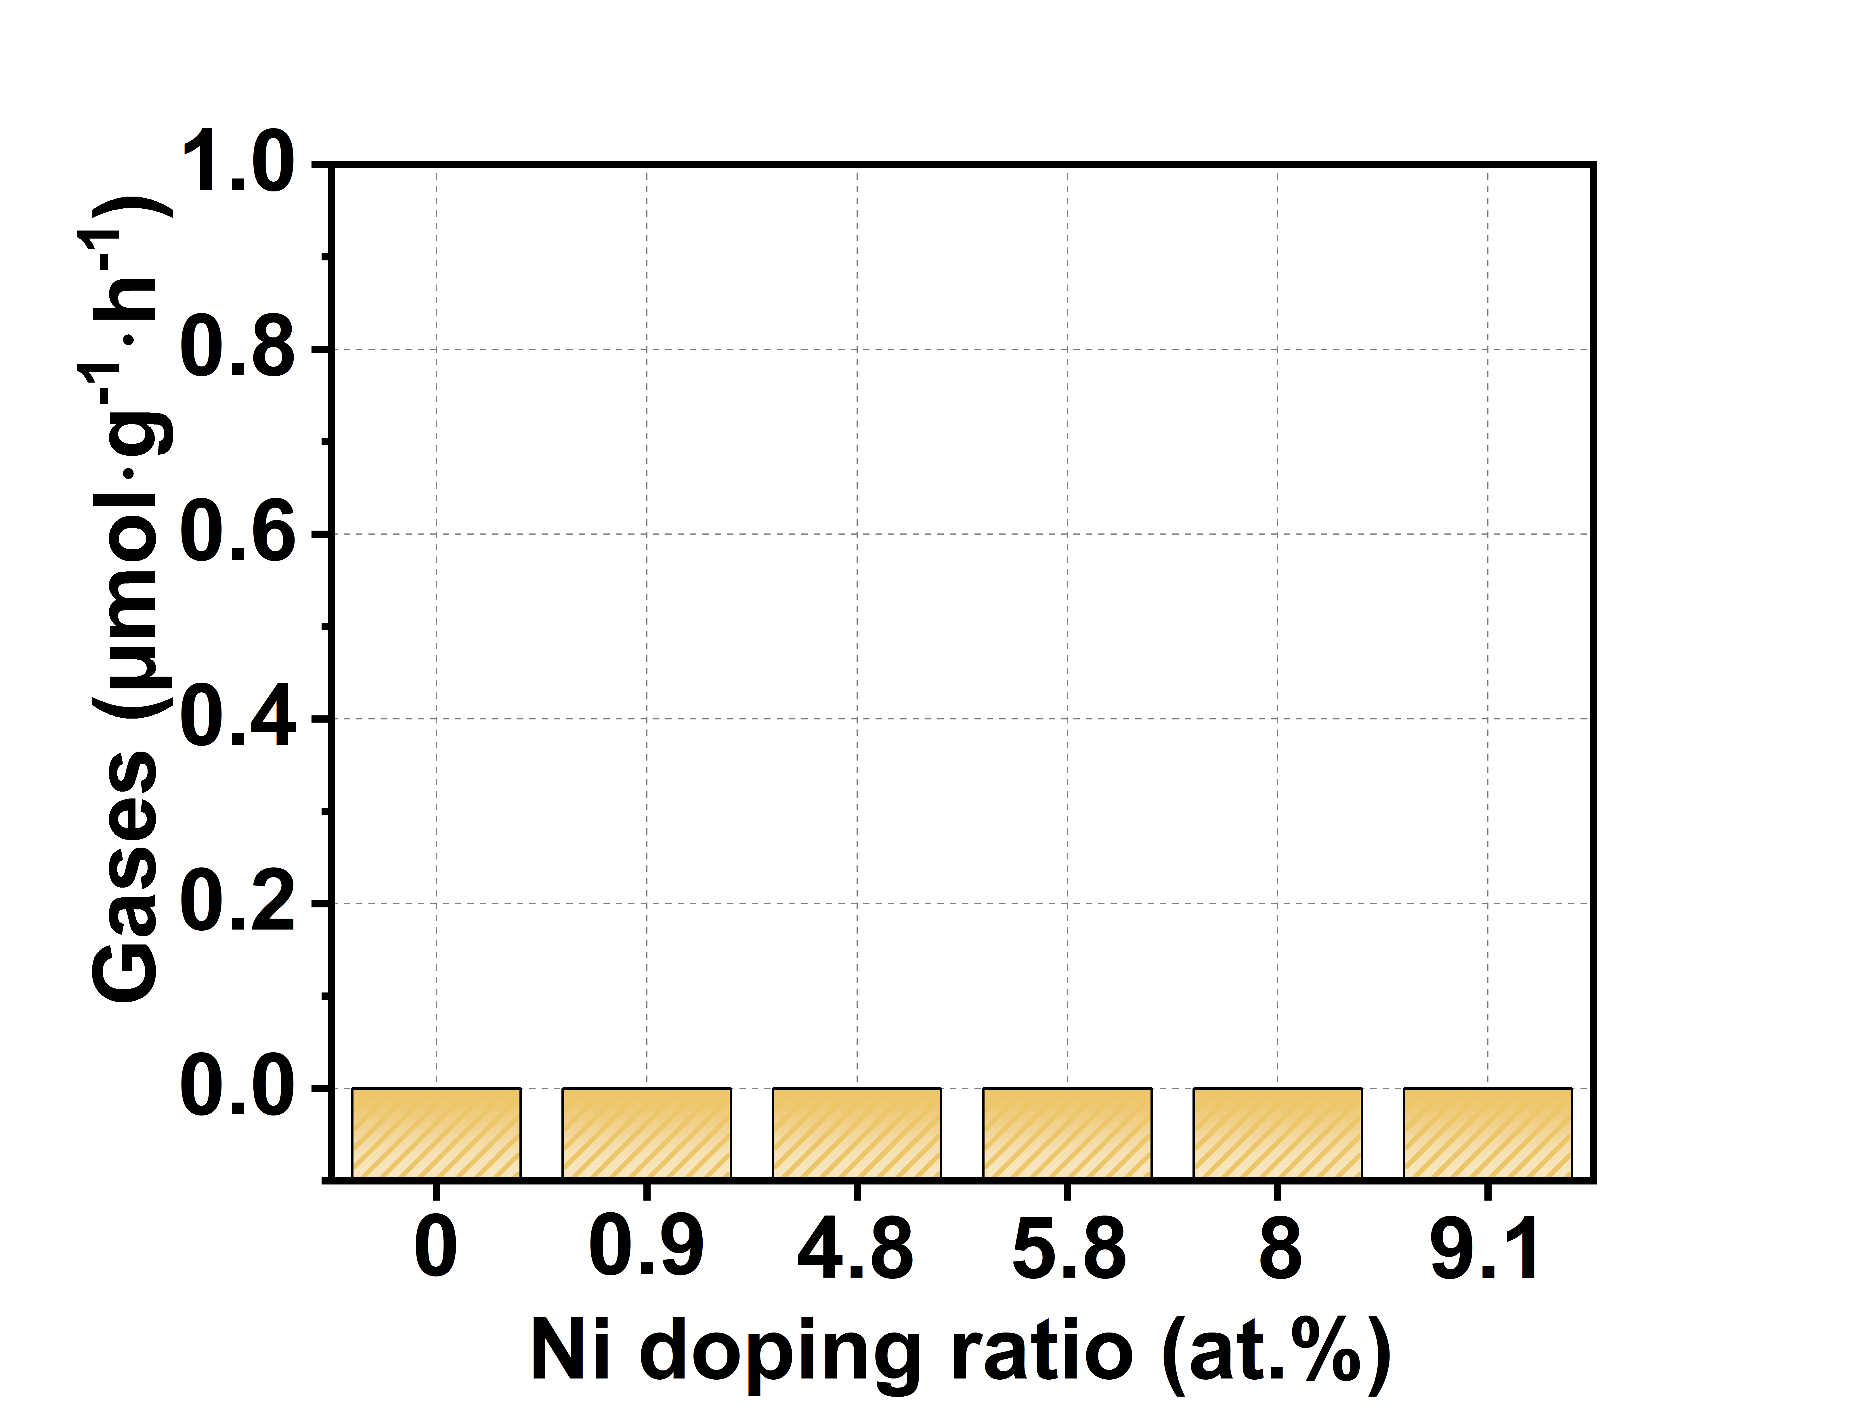
Figure S4 The product yields of Ni-CsPbCl₃ with various Ni doping ratios in an argon atmosphere.

S5 Tauc Plot of the catalysts. The method for obtaining Tauc Plot by UV-VIS absorption mapping: Convert the wavelength (𝜆) to photon energy (ℎ𝜈) using the relation: hν= hc/ 𝜆. Plot (Aℎ𝜈)^{𝑛} on the y-axis against hν on the x-axis. The optical band gap (𝐸_{𝑔}) is determined by extrapolating the linear portion of the Tauc plot to the x-axis (where (Aℎ𝜈)^{𝑛} =0). The intercept on the x-axis gives the band gap energy.
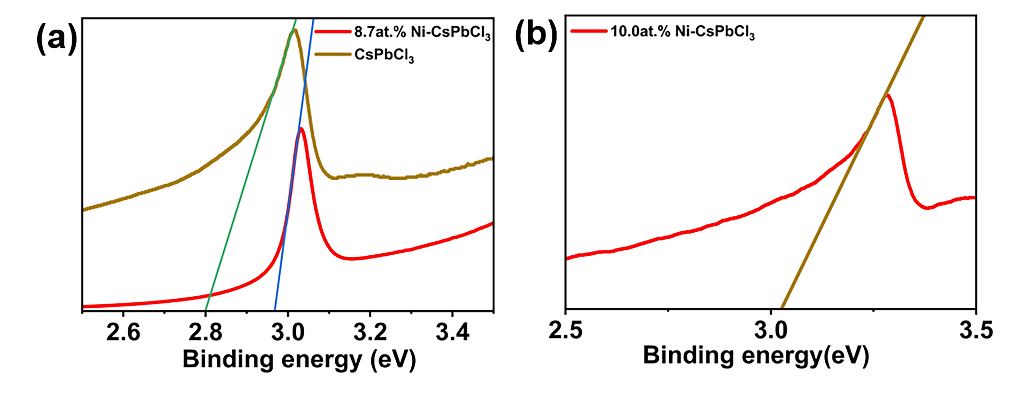
Figure S5 (a) Tauc Plot of CsPbCl₃, Ni-CsPbCl₃ with a doping ratio of 8.0 at. % and (b) Ni-CsPbCl₃ with a doping ratio of 9.1 at. %.

Figure S6 XRD of Ni-CsPbCl₃ with a doping ratio of 8.0 at. % and Ni-CsPbCl₃ with a doping ratio of 9.1 at. %.
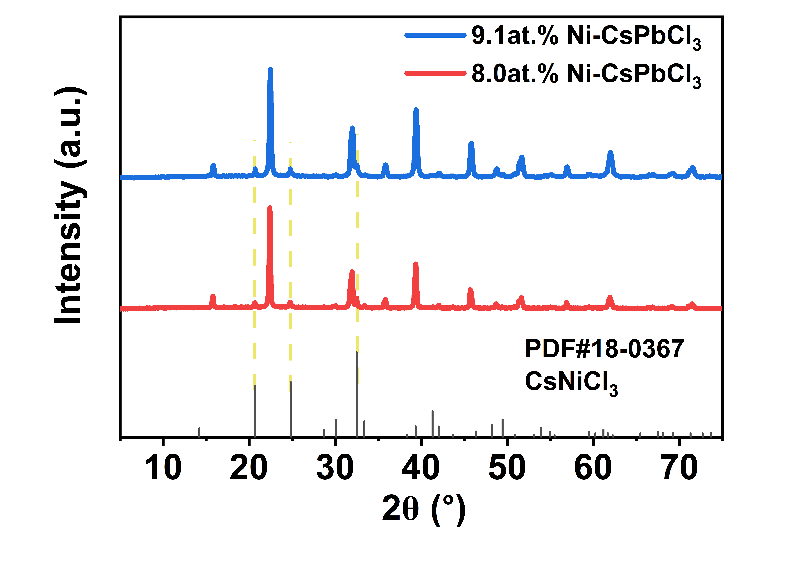
Figure S6 XRD of Ni-CsPbCl₃ with a doping ratio of 8.0 at. % and Ni-CsPbCl₃ with a doping ratio of 9.1 at. %.
Figure S7 XRD of CsPbCl₃ before and after reaction.
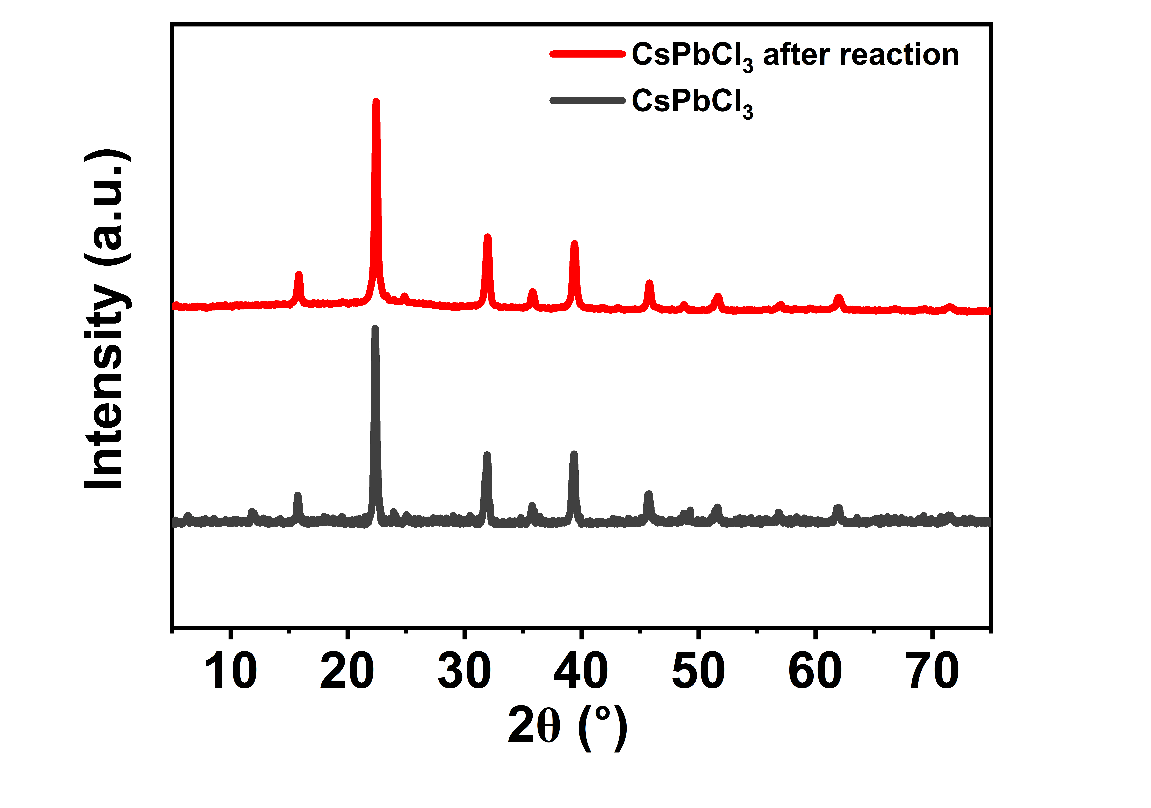
Figure S7 XRD of CsPbCl₃ before and after reaction.

Table S1 Atomic doping ratio corresponding to each feeding ratio.
Feed ratio (molar ratio) | Ni doping ratio (at. %)
1:1 | 0.9
2:1 | 4.8
3:1 | 5.8
4:1 | 8.0
5:1 | 9.1

Table S2 Summary of the photocatalytic CO₂ reduction performance of perovskite.
Photocatalyst | Reaction medium  (Reaction system) | Products and Yield  (μmol g⁻¹h⁻¹) | Stability time (h) | Refs
Ni-CsPbCl₃  （500mT） | CO₂/H₂O vapor  (solid–gas) | CO:27.3 | 36 | This work
Ni-CsPbCl₃ | CO₂/H₂O vapor  (solid–gas) | CO: 3.8 | 36 | This work
Cs₄Pb₃Br₁₀  Cs₅Pb₄Br₁₃ | CO₂/H₂O vapor  (solid–gas) | CO: 9.14, CH₄: 0.7  CO:13.57, CH₄: 0.64 | 30 | [1]
Mn-CsPbBr₃ NPLs | CO₂/H₂O vapor  (solid–gas) | CO: 7.56,  CH₄: 0.58 | 24 | [2]
Cu: CsPbBr₃ | CO₂/H₂O vapor  (solid–gas) | CO: 0.53 ± 0.08,  CH₄: 14.72 ± 0.60 | 5 | [3]
CsPbBr₃/Pd | CO₂/H₂O vapor  (solid–gas) | CO: 5.77,  CH₄: 10.41,  H₂: 3.29 | 3 | [4]
Reference
[1] Lin C-C, Li J-Y, She N-Z, et al., Stabilized High-Membered and Phase-Pure 2D All Inorganic Ruddlesden–Popper Halide Perovskites Nanocrystals as Photocatalysts for the CO₂ Reduction Reaction. Small, 2022, 18 (19): 2107881.
[2] Lin C-C, Liu T-R, Lin S-R, et al., Spin-Polarized Photocatalytic CO₂ Reduction of Mn-Doped Perovskite Nanoplates. J Am Chem Soc, 2022, 144 (34): 15718-15726.
[3] Bian H, Liu T, Li D, et al., Unveiling the effect of interstitial dopants on CO₂ activation over CsPbBr₃ catalyst for efficient photothermal CO₂ reduction. Chem Eng J, 2022, 435: 135071.
[4] Xu Y-F, Yang M-Z, Chen H-Y, et al., Enhanced Solar-Driven Gaseous CO₂ Conversion by CsPbBr₃ Nanocrystal/Pd Nanosheet Schottky-Junction Photocatalyst. ACS Appl Energy Mater, 2018, 1 (9): 5083-5089.

